Ana Karina Ballesteros Gómez
Biologist and Computational Biologist
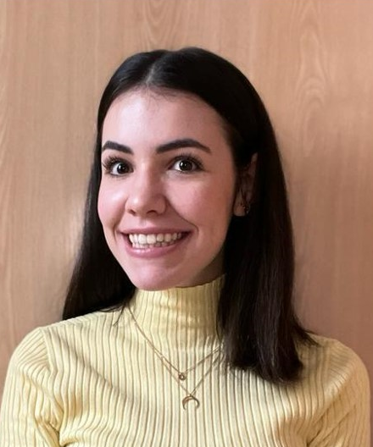
Computational biologist interested in data science field in the biomedical research and the development of new technologies for the improvement of the health sector.

anak.ballesteros@hotmail.com

PROFESSIONAL PROFILE

Graduated in Biology in the Universidad Autónoma de Madrid (UAM) in 2022, focused on the fields of Cell Biology and Genetics. During my Degree I had the opportunity to gain training with several molecular laboratory techniques, and I started realizing the importance of data analytics as a powerful and complementary tool for the biology field. This idea was reinforced during my last year ́s Degree when I had the opportunity to work with the Lymphoma research group of the Instituto de Investigación Sanitaria Puerta de Hierro - Segovia de Arana (IDIPHISA). Here, I prepared DNA libraries for next generation sequencing (NGS) and carried out the bioinformatic analysis of processing and filtering of NGS databases and statistical analysis of results using R for estimating the predictive and prognostic value of circulating tumor DNA for follicular lymphoma patients.
The attraction of combining biology with data science led me to pursue the Master´s degree in Computational Biology at the Universidad Politécnica de Madrid (UPM). During this Master I have not only improved my skills on AI and Data Science, project management, funding opportunities and learned different bioinformatics techniques, but I understand aspects beyond biology as well as the importance of the use and development of new technologies that allow us to have the information and data more interconnected.
I am currently working on my Master's Thesis in the imAIgene-lab group in the Instituto de Investigaciones Biomédicas Alberto Sols (IIBM, CSIC), where I am developing a user friendly deep learning-based morphometric unmixing model for multiplex 3D imaging data using Python as the underlying programming language.

