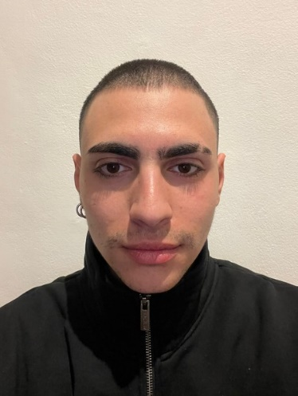
A N G E L O D ' A N G E L O
C O M P U T A T IO N A L B IO L O G IS T
CONTACTS:
Number: +393292761923
angelo.dangelo@alumnos.upm.es

Picture can be improved

PROFILE ABOUT ME

With a strong foundation in Bioinformatics and Computational Biology, I am passionate about utilizing cutting-edge technologies to make a positive impact on human health.

COMPETENCES

Proficient in data analysis using R and Python programming languages
Experience in RNA-seq data analysis
Skilled in drug design and
molecular modeling techniques Strong understanding of biological systems and their interactions
Familiarity with various bioinformatics tools and databases
Ability to collaborate with interdisciplinary teams for research projects.

As a Bioinformatics and Computational Biology professional, I bring a diverse background and a breadth of skills to the table. I received a 110 with honor in Bioinformatics from la Sapienza University of Rome and went on to conduct my Bachelor Thesis on RNA-seq analysis of cardiomyocytes, focusing on the role of long non-coding RNA (Charme) in human cells. I further conducted bioinformatic analysis and motif search to identify Charme's protein interactors. Building on this experience, I pursued my studies in Spain, where I expanded my expertise in genomics, data visualization, drug design, big data, synthetic biology, biocomputing, machine learning, and drug design.

I possess a strong technical skill set in data analysis, statistical modeling, and programming languages such as Python and R, as well as valuable soft
skills, such as effective communication, collaboration, and problem-solving. I have proficiency in software for drug design, such as Chimera, for binding and pharmacophore screening purposes. I have extensive experience in working with biological databases, such as Uniprot, to conduct data retrieval, analysis, and interpretation.

My career aspiration is to further deepen my knowledge and experience in data analysis and machine learning models to gain biological insights into the mechanisms underlying the data. I am particularly interested in leveraging my expertise to develop tools for clinical and diagnosis purposes, allowing me to make a significant impact on human health. With a focus on effective
communication, collaboration, and attention to detail, I am well-equipped to work in multidisciplinary teams and deliver results.

Currently, I am conducting my thesis on APEX-se, a new technique for spatial localization of RNA. Specifically, I am focused on stress granules and the differences between normal FAS and mutated FAS related to Amyloid lateral sclerosis. With a strong foundation in biopython, Python, and R, I am well- equipped to conduct complex data analysis and develop machine learning
models to gain insights into biological mechanisms underlying the data. Additionally, I have experience in software for drug design and working with biological databases.

I am passionate about utilizing cutting-edge technologies and techniques to gain biological insights and make a positive impact on human health. With my skills and experience, I am excited about the potential of my current research and I am eager to apply the knowledge and expertise I gain to advance the field of Bioinformatics and Computational Biology.

