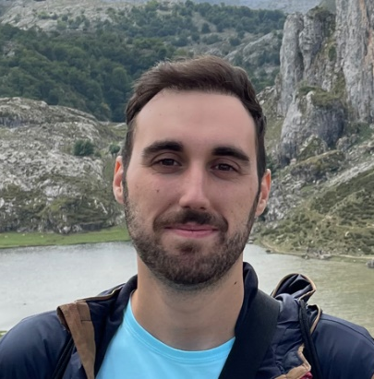

Name: Pablo Mata Aroco
Contact: pyblus@gmail.com

Brief description: Pharmacist graduated in 2022 from Universidad Complutense de Madrid (UCM) with a deep background on Computational Biology, Bioinformatics, and Machine Learning. Looking for a job on genomic data analysis and personalized medicine.
I’m a highly motivated and enthusiastic professional who completed my studies of bachelor’s degree in pharmacy from the prestigious Complutense University of Madrid in 2022 and currently pursuing the Master's degree in Computational Biology from Technical University of Madrid (UPM). With a strong passion for genomic data analysis and machine learning, I am specifically interested in the field of bioinformatics and its application to personalized medicine and health care.
I completed a 9-month internship within the Bioinformatics Unit at ISCIII (Carlos III’s Health Institute), where I was responsible for conducting research to identify potential targets for the serological diagnosis of Trichinella sp parasite that cause the trichinosis disease. This experience provided me with a deep understanding of the bioinformatics tools and techniques required for genomic analysis, differential gene expression analysis and predictions for epitopes, protein secretion and antigenicity.
Currently, I am undertaking a practical internship at the same unit in ISCIII, where I am learning how to build Nextflow pipelines for Whole Genome Sequencing (WGS) data analysis on SARS-COV-2. Additionally, I am gaining valuable experience in the management and processing of data on a High-Performance Computing (HPC) cluster environment, using Slurm queue manager.
In addition to my academic and practical experience, I am also a certified deep learning practitioner, having completed the course certification from deeplearning.ai. This certification demonstrates my commitment to staying current with the latest technologies and advancements within the field of bioinformatics such as AI implementation.
Overall, I possess a strong background in pharmacy, combined with extensive knowledge and experience in computational biology, bioinformatics, and genomics data analysis. With a passion for personalized medicine and healthcare, I am dedicated to advancing my skills and knowledge to contribute to this field's growth and development. I am confident that my skills and experience make me an excellent candidate for a bioinformatics technician role.

