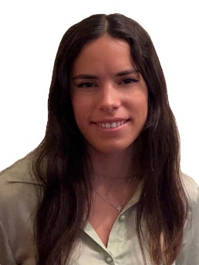
Marina Ortega Angulo
These years have taught me and left me with an idea that I want to keep in my work: always keep an open mind and face everything with the desire to learn.
As a graduate in Computational Biotechnology from the Polytechnic University of Madrid I have acquired extensive knowledge in the field of biology as well as learning techniques for experimental work as western blots, qPCR, electrophoresis ... but thanks to the specialty I chose I have acquired knowledge that differentiates me from other graduates in this field. In this degree I acquired advanced knowledge in programming (Python, SQL and R) and in the use of applications or techniques that relate computation with biology such as protein treatment programs for the prediction of their structure, interactions... I expanded mi knowledge in these applications in my internship in the CBGP-UPM-INIA center in the research group of plant allergens when I studied the participation of the Alt a 1 protein of Alternaria alternata and its ligand in the immune response.
This experience in the field of computation and the desire to continue learning led me to study the master's degree in Computational Biology at the Polytechnic University of Madrid, which I am currently studying and in which I have increased my knowledge in Python and R, especially in working with machine learning.
This desire to keep growing has led me to participate in the 'Talent Graduate Program' in Sanofi, one of the leading pharmaceutical companies in the world, where I am a member of the quality team of iShift, we are part of the GIC (Global Innovation Center) and therefore the idea of the beginning, I am playing a role that I had never done before but the pleasure of continuing to learn has allowed me to improve in this area and find another way that I like and in which to continue to develop as a professional.
E-mail: marina.10.maor@gmail.com
LinkedIn: Marina Ortega Angulo

